LT 428

Component Digital Sync Generator

Instructions
for
Production



Content

Content 2
Production Process Overview 3
Responsibilities 4
Test and Adjustment Process 5
Test and Adjustment Program for LT428 Component Digital Sync Generator. 6
Introduction. 6
Power Supply Check. 6
Reset Sync Pulse Generator. 6
Adjust 13 MHz TCXO. 6
Calibration of Genlock Color Framing. 6
Check Genlock. 7
Black Burst Generator Adjustment. 7
TSG Luminance Calibration. 7
TSG Timing Adjustment. 7
TSG Pattern Check. 7
SDI Jitter and Amplitude Spectrum Check. 8
SDI Embedded Audio Check. 8
Analog Audio Level Calibration. 8
Analog Audio Frequency Check. 8
AES Audio Generator Test. 8
AES Audio Level Check. 8
Word Clock Output Test. 8
Appendix A 9
List of Test Instruments 9
Appendix B 10
Summary of accuracies and nominal values 10
Final mounting and Safety inspection 11
Internal mechanical checks 11
Mounting of top cover 11
Safety tests 11
Packing Instructions for LT428 12
Serial Number 12
Warning Label 12
Mains Supply Label 12
Accessories 13
Box Labels 13
Box Sealing and Shipment Boxes 13
Spare Parts 14
Parts for Board Swapping and Mechanical Repairs 14

Production Process Overview
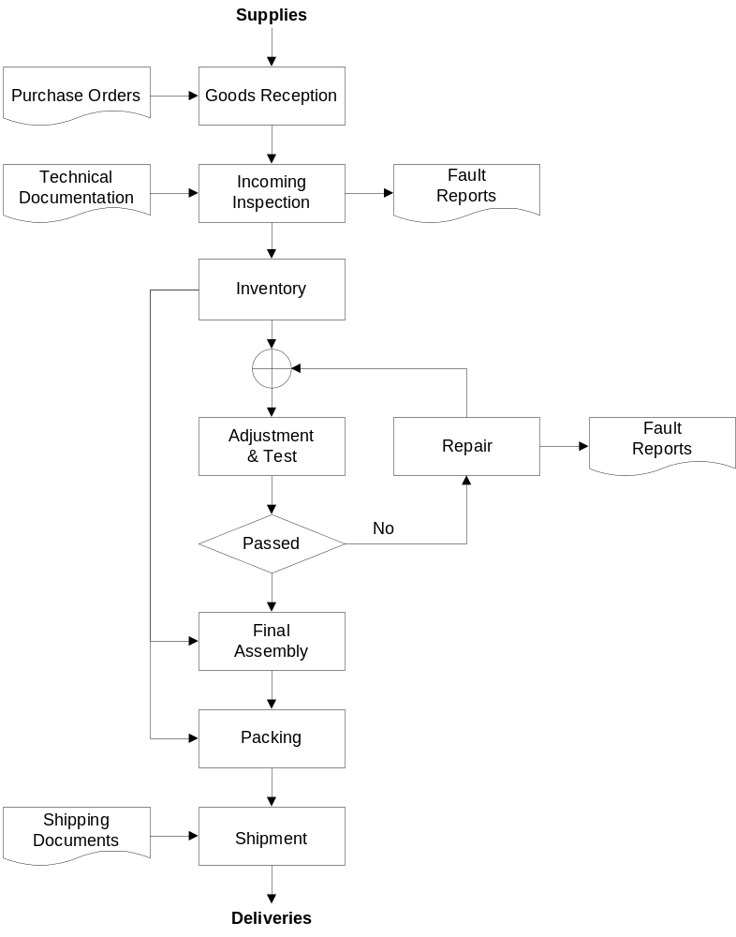

Responsibilities

Process | Stores | Test | Purch. | Eng. | Sales
Goods Reception | X
- Purchase Orders |  |  | X
Incoming Inspection | X
- Technical Documents |  |  |  | X
- Fault Reports | X
Inventory | X
Adjustment & Test |  | X
Repair |  | X
- Fault Reports |  | X
Final Assembly |  | X
Packing | X
Shipment | X
- Shipping Documents |  |  |  |  | X

Test and Adjustment Process
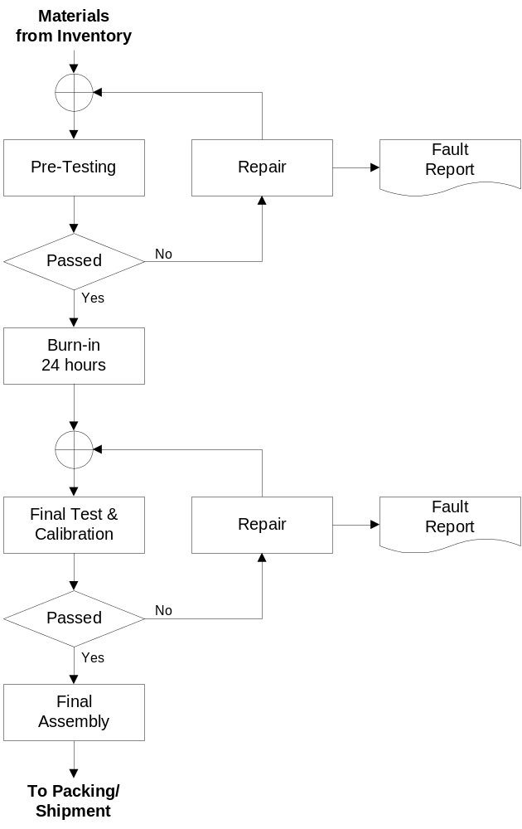

Test and Adjustment Program for LT428 Component Digital Sync Generator.

Introduction.
The design of LT428 is fully digital with 3 microcomputers controlling synthesis of all its signals. There are no manual adjustments (like potentiometers, variable capacitors, coils, etc). All parameters necessary for signal synthesis reside as variables in a non-volatile memory. After assembly at the factory, these variables have to be properly initialized for each generator produced.

To do this, a dedicated test bench was built consisting of various instruments controlled by a PC through serial, parallel and GPIB interfaces. A test program running on the PC instructs an operator on how to connect and use the instruments, reads the instruments, calculates all necessary parameters and writes them into LT428's memory.

LT428 parameters are also checked to be within specified tolerances.
If all adjustments and checks are positive, a report is created in form of a file.

Below follows a short description of all test procedures.

Power Supply Check.
Three power supply values: 5 volt, 3.3 volt and -5 volt are checked to be within tolerances:
4.8V to 5.2V
3.168V to 3.432V
-5.2V to -4.8V

Reset Sync Pulse Generator.
The Sync Pulse Generator is the main part of the LT428; it's purpose is to generate various synchronization signals for black-burst, color and AES/EBU generators. The SPG has its own microcomputer and utilizes a RAM based PLD which has to be programmed from the master controller. Reset SPG procedure initializes the SPG microcomputer.

Adjust 13 MHz TCXO.
The 13 MHz Temperature Compensated Crystal Oscillator serves as a frequency reference for LT428. It is a voltage-controlled oscillator; the control voltage is obtained from a DAC connected to SPG microcomputer. To adjust the oscillator, Black Burst 1 is set to output a 4.5 MHz sinus signal, which is derived from oscillator's 13 MHz signal. This 4.5 MHz signal is fed to a frequency counter and the oscillator’s control voltage is changed until BB1 emits 4.5 MHz ±0.2Hz. The DAC output voltage and hertz/step value are also checked to be within tolerances (from 0V to 1.5V and bigger than 0.05 Hz/step). The frequency counter used (HP53132A) uses a 10 MHz reference signal coming from a GPS receiver.

Calibration of Genlock Color Framing.
This involves calculation and setting of variables in SPG microcomputer, which control horizontal position of the Black Burst Signals in relation to the genlock signal. LT428 Genlock input is fed from an external generator with a PAL black burst signal with ID. The Black Burst output is set to PAL with ID. Both signals are observed on an oscilloscope. The variables are adjusted until the IDs on both signals are in phase. The procedure is then repeated for NTSC.

Check Genlock.
Here the ability to lock to different signals is tested. LT428 Genlock input is fed from PM5640 Video Test Signal Generator, which is programmed to give signals with different sync and burst amplitudes, with hum and noise superimposed.
Genlock state is tested under following conditions:

PAL Genlock - Burst 150 mV, Sync 180 mV, Hum 500 mV, Noise -40 dB
PAL Genlock - Burst 600 mV, Sync 600 mV, Hum 500 mV, Noise -40 dB
NTSC Genlock - Burst 20 IRE, Sync 24 IRE, Hum 50 IRE, Noise -40 dB
NTSC Genlock - Burst 80 IRE, Sync 80 IRE, Hum 50 IRE, Noise -40 dB
10 MHz Genlock – 1.5 Vpp
10 MHz Gen-lock – 0.5Vpp

Black Burst Generator Adjustment.
mVperStep for BB Sync Level DAC is checked to be between 0.1 and 0.4 mV/step.
mVperStep for BB offset DAC is checked to be between 0.2 and 1.0 mV/step.
Level of BB signal's sync level is checked to be -300 ± 2 mV.
DC level superimposed on the BB signal is checked to be 0 ± 3 mV.

The LT428 Genlock input is fed from a reference Black Burst signal.
The BB signal is fed to a Vectorscope (for ScH measurement) and to input A of a Waveform Monitor. Input B of the Waveform Monitor is fed with LT428 Genlock output (reference BB signal) and the monitor is set to display the difference between its 2 inputs. The operator adjusts ScH Offset until the Vectorscope shows 0, then Phase Offset and Gain until Waveform monitor shows a straight line, i.e. Black Burst and the reference signal are in phase.
Calibration of Burst amplitude and SC-H phase checked on VM700:
Burst amplitude within ±1%
SC-H phase within 1°
If values outside tolerance, parameters are readjusted

TSG Luminance Calibration.
mVperStep for TSG Level DAC is checked to be between 0.15 and 5.0 mV/step.
TSG level is measured to be of 700 ± 0.2 mV for PAL and
714 ± 0.2 mV for NTSC.

TSG Timing Adjustment.
The LT428 Genlock input is fed from a reference Black Burst signal.
The TSG signal is fed to a Vectorscope (for ScH measurement) and to input A of a Waveform Monitor. Input B of the Waveform Monitor is fed with LT428 Genlock output (reference BB signal) and the monitor is set to display difference between its 2 inputs. The operator adjusts ScH Offset until the Vectorscope shows 0, then Phase Offset and Gain until Waveform monitor shows a straight line, i.e. TSG and the reference signal are in phase.
Calibration of Burst amplitude and SC-H phase checked on VM700:
Burst amplitude within ±1%
SC-H phase within 1°
If values outside tolerance, parameters are readjusted

TSG Pattern Check.
All patterns available in TSG generator are sequentially displayed on a video monitor. The operator checks and confirms that they are as specified.

SDI Jitter and Amplitude Spectrum Check.
Jitter of the SDI signal is tested on R&S VCA (Digital Video Component Analyzer). Measurements are made during 4 frames and during 1 line.
For 4 frames the jitter must be less than 0.15 UI.
For 1 line the jitter must be less than 0.07 UI.
Jitter is tested under the following conditions:
Internal genlock
PAL genlock
10 MHz Genlock

Then the spectrum test is performed on VCA in the range of 10 - 350 MHz.
At 10 MHz the level must be within -0.65 to 0.65 dB.
At 350 MHz the level must be less than -12 dB.

SDI Embedded Audio Check.
TEK 764 Digital Audio Monitor is used. V BIT (Validity Bit) must be set.

Analog Audio Level Calibration.
Nominal audio level is set to be 1550.0 V ±5 mV.
mV per step of digital potentiometers is checked and must be within 1 and 6 mV/step.

Audio levels checked: +8, +4, 0, -6, 12 and –18 dBu (frequency 1 kHz)

All analog audio levels are checked at 1 KHz to be within ±0.3 dBu.
Audio amplitude check for 500 Hz, 1 kHz and 8 kHz::
Level: 775 mV ± 15 mV.

Analog Audio Frequency Check.
The tolerance of analog frequency is ±1 Hz. The check is performed for level of 0 dBu at frequencies 500 Hz, 1 kHz and 8 kHz.

AES Audio Generator Test.
VCO voltage is tested at 6.144 and 5.6448 MHz to be between -2.0 and 1.0 V.
Then, frequencies of stereo tones of 500 Hz, 1000 Hz and 8 kHz at sampling rates of 48 kHz and 44.1 kHz are tested to be within ± 0.2 Hz.

AES Audio Level Check.
All AES audio levels are tested with the TEK 764 monitor. The operator reads measured level and either accepts or rejects the result. The accuracy of the monitor level meters is ± 0.05 dB.

Word Clock Output Test.
The frequency of Word Clock is checked to be of 48 kHz ± 0.2 Hz.
Peak-to-Peak value of Word Clock voltage is checked to be between 2.2 and 2.7 V.
Peak-to-Peak value of Word Clock offset voltage is tested to be between 1.0 and 1.5 V.

Appendix A

List of Test Instruments

Type | Serial No. | Description | Manufacturer
PM 5640G | TEST | Video Test Signal Generator | PTV
PM 5640M | TEST | Video Test Signal Generator | PTV
PM 5662G | TEST | Waveform Monitor / Vectorscope, ScH | PTV
PM 5662M | TEST | Waveform Monitor / Vectorscope, ScH | PTV
PM 3094 | DM707001 | Oscilloscope | Fluke
VCA | 338275/024 | Digital Video Component Analyzer | R&S
764 | B021638 | Digital Audio Monitor | Tektronix
PT 5210 | TEST | Digital Video Generator | PTV
53132 | 3736A05798 | Frequency Counter | HP
34970A | US37028651 | Data Switch | HP
DEX3072 | - | Digital Audio Extractor | Matthey
- | 061-0304 | SDI to Analog Converter | Miranda
CVM22B | 5091104 | Color Monitor | Barco
- | TEST | Video Level Meter | Philips
34401A | US36139206 | Multimeter | Agilent
XL-DC | 98214681 | GPS Receiver | True Time

Appendix B

Summary of accuracies and nominal values

Master Frequency
Accuracy @ 4,500,000 Hz: ± 0.2 Hz

Black Burst (Values for both PAL and NTSC)
mVperStep of BB Sync Level DAC: 0.1 - 0.4 mV/step
mVperStep of BB Offset DAC: 0.2 - 1.0 mV/step
BB Sync Level: -300 ± 2 mV
BB Offset: 0 ± 3 mV

TSG
mVperStep of TSG Level DAC: 0.15 - 5 mV/step
TSG Level PAL: 700 ± 2 mV
TSG Level NTSC: 714 ± 2 mV

SDI Jitter
4 frames: < 0.15 UI
1 line: < 0.07 UI

SDI Amplitude Spectrum
@10 MHz Level: -0.65 - 0.65 dB
@350 MHz Level: < 12 dB

Calibration of Analog Audio Levels
Nominal Level for +6dBu 1550.0 mV
Level Tolerance for all levels ± 5 mV
mVperStep Digital Potentiometers: 1 - 6 mV/step

Check of Analog Audio Levels
Level Tolerance for all levels @ 1kHz: ± 0.3 dBu

Analog Audio Frequency
Tolerance (@0 dBu, 500 Hz, 1 kHz, 8 kHz): ± 1 Hz

AES Audio
Frequency tolerance: ± 0.2 Hz

Word Clock
48 kHz frequency tolerance: ± 0.2 Hz
P-P voltage: 2.2 - 2.7 V
P-P offset voltage: 1.0 - 1.5 V

Final mounting and Safety inspection

Internal mechanical checks
- Check all internal screws are mounted.
- Check safety leads of power supply
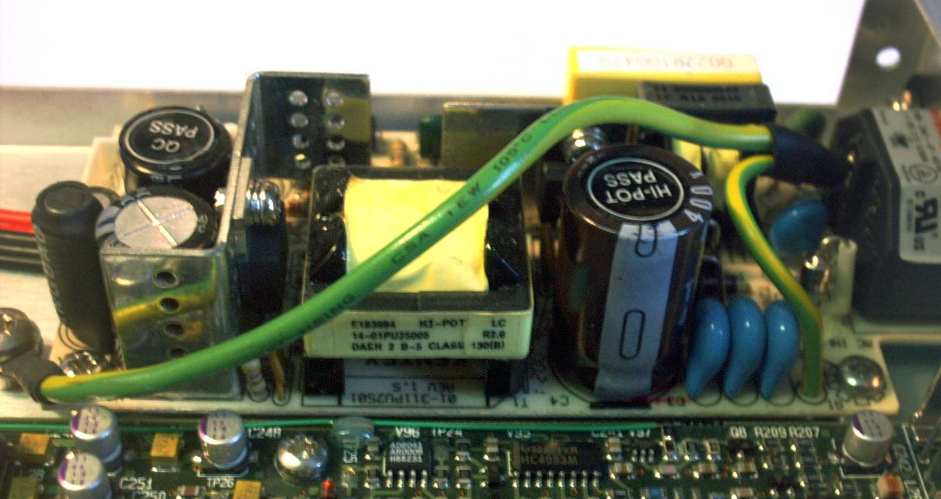

Mounting of top cover
- Make sure that light pipes are positioned correctly in the holes of the frontplate.
- All screws M2.5x 4, part number 2522 187 62040
- Fix screws securely.

Safety tests
- Continuity test between chassis and ground of power inlet
Requirement: Resistance < 0.5 Ohm.
- Isolation resistance:
Apply 500V DC between shortcircuited mains inlet and ground terminal.
Measure with mA-meter: less than 0.25 mA
- High tension test:
Apply 2500V DC for 1 minute between shortcircuited mains inlet and chassis.
No flashes must occur (checked with mA-meter)
- Leak current during operation:
At max. Mains +10% measure current with mA-meter
Requirement: < 1mA.

Safety data is recorded on the instruments “process” card.

After the safety test is passed, the “process” card is completed with date and operators name. Small green label (part number 4022 006 70890) is fixed to the rear close to the mains inlet and signed by the operator.

Checking after safety test:
A brief functional testing is performed on all inputs and outputs.

Packing Instructions for LT428

Serial Number

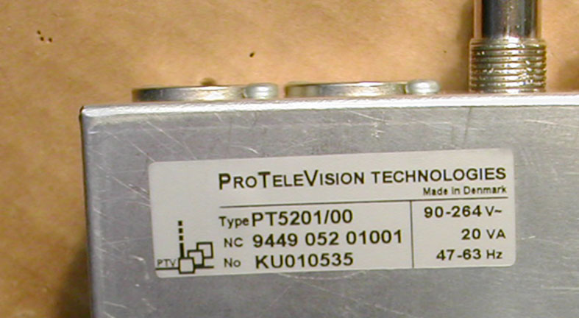

The serial number label is placed on the bottom under the AUDIO connectors.

The serial numbers to be applied are informed by Leader.
Serial no. of 1st batch (Sept. 2000- Dec. 2002): 3947576 through 3947625.
Serial no. of 2nd batch (Febr. 2003): 3477153 through 3477202.
Serial no of 3rd batch (June 2003): 3287980 - 3287999 and 3387000 - 3387029

Warning and Caution Labels
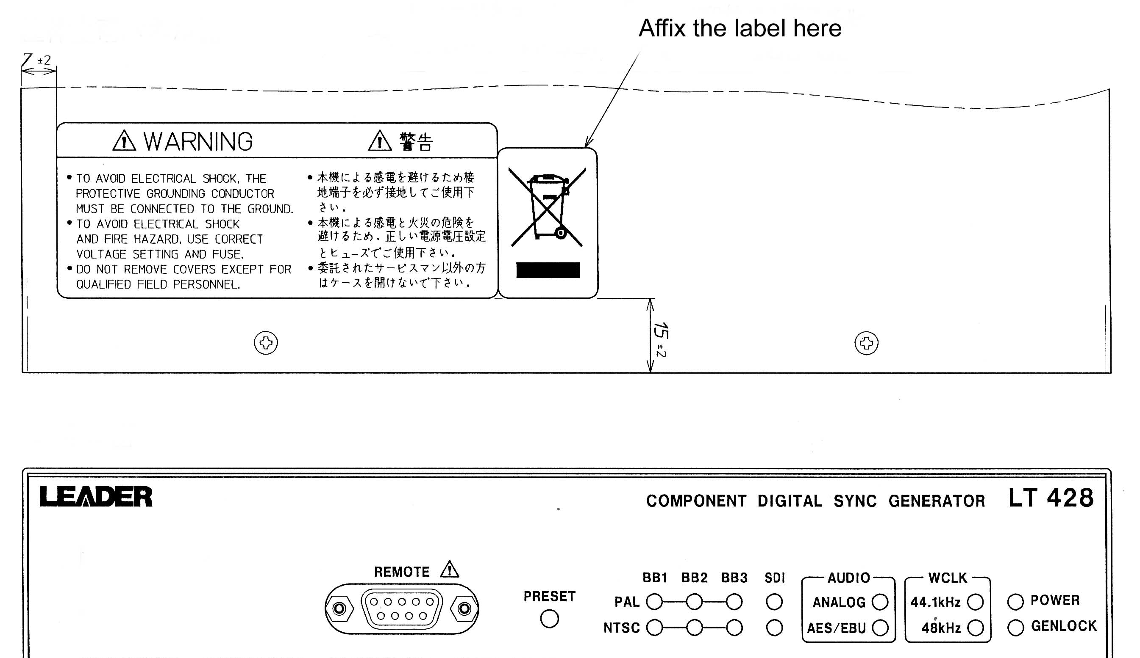
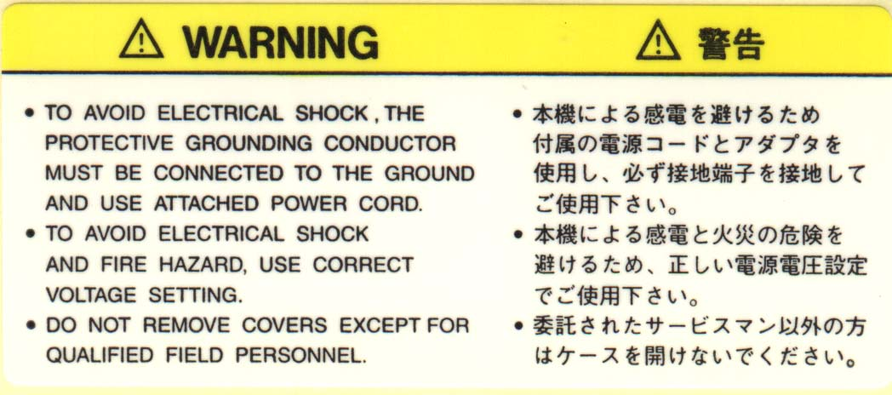
The warning and WEE labels are placed on the cover at the front.

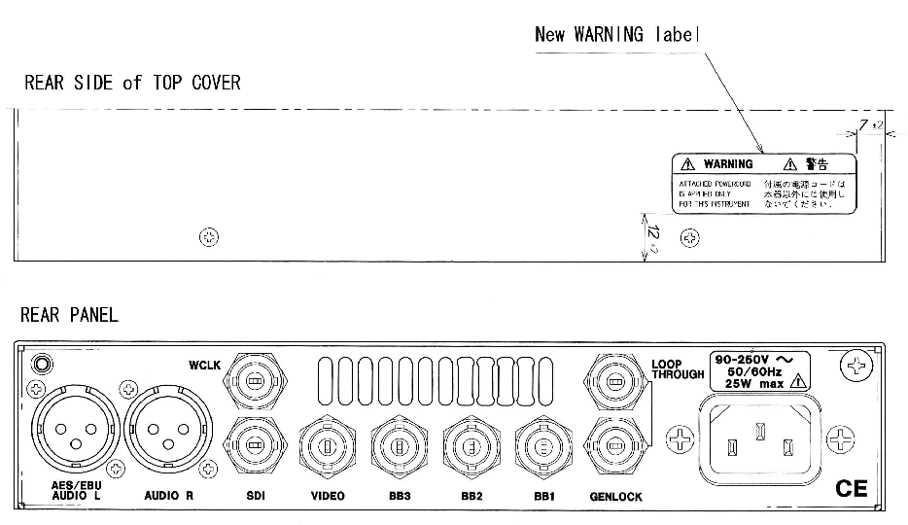
The Caution label is placed on the cover at the rear.

Mains Supply Label

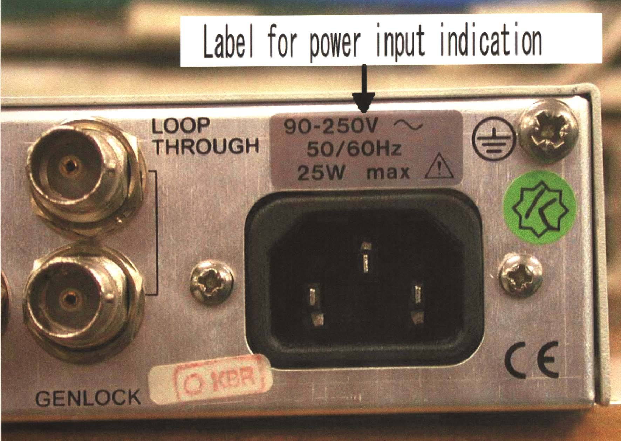
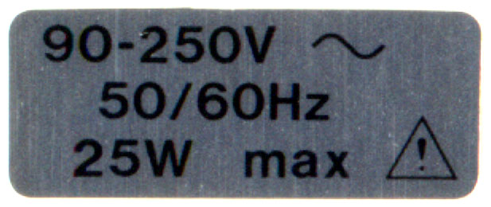

The Mains Supply Label is placed on the rear plate above the mains inlet socket.

Accessories
The accessories for LT428 consist of the following parts:
Qty | Part no. 12NC | Description
 | 4008 109 90010 | Accessories, consisting of:
1 | 4008 105 00020 | US mains cord gray
1 | Leader inserts | 3P to 2P mains adapter
1 | 4008 105 05220 | RS232 Interface Cable
1 | 4008 002 96000 | CD-ROM for LT428 (Leader P/N 8045022019)
1 | 4008 002 96010 | CD-ROM cover for LT428
1 | 4008 107 60060 | Rack Mount Kit

Box Labels
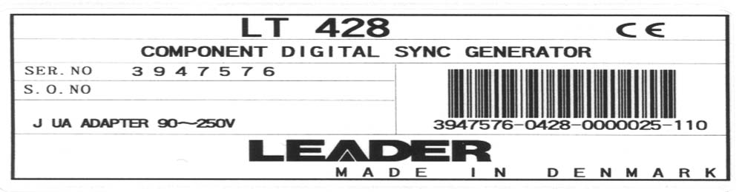
Two (2) labels are placed on each carton box.

NB: The serial number on this label shall correspond to the serial number on the instrument in the box.

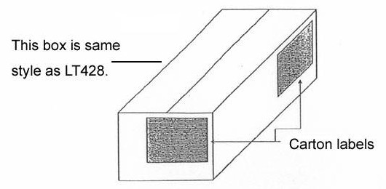

Box Sealing and Shipment Boxes
The carton boxes shall be closed with clear tape. No stapling.

The carton boxes with the LT428 shall be packed for shipment in another carton box, which is marked according to DK-Audio/PTV standard export packaging.

Spare Parts

Parts for Board Swapping and Mechanical Repairs

Part Number | Description | New | Refurbished
4008 109 86650 | Power Supply Assy | X
4008 109 90080 | Main Board Assy | X | X
4008 107 59380 | Top Cover | X
4008 127 04200 | Outer Case w/Text | X
4008 108 56510 | Front w/Overlay | X
Note:
Mainboard assy 4008 109 90080 is superceeding 4008 109 86660

